**Module**

**in**

***PATHFit 1 (MIDTERM)***

**Physical Activities Toward Health and Fitness 1 (Movement Competency)**

1st Semester 2023-2024

Prepared by:

Amaranto, Jeff C.

Baligat, Loraine G.

Cabacungan, Nina A.

Talania, Aldrin S.

**UNIT 2**

**Understanding Human Movement**

**Anatomical Reference Position and Perspective in Movements**

What are the key details about anatomical position?

Anatomical position is the position of the body when it is standing straight up, palms facing front, with both arms hanging by its sides. Feet are flat on the ground and looking forward. Legs are parallel. When discussing specific anatomical words and postures, the anatomical position is a common standard point of reference used in human anatomy and physiology. The head, neck, torso, upper extremities, and lower extremities make up the five sections of the body. The body is also divided by three imaginary planes known as the *sagittal plane*, *coronal plane*, and *transverse plane*. The sagittal plane runs vertically and divides the body into *right and left portions*. The coronal plane runs vertically, separating the body into a *front and a back half*. Finally, the transverse plane runs horizontally and separates the body into a *top and a bottom half*.

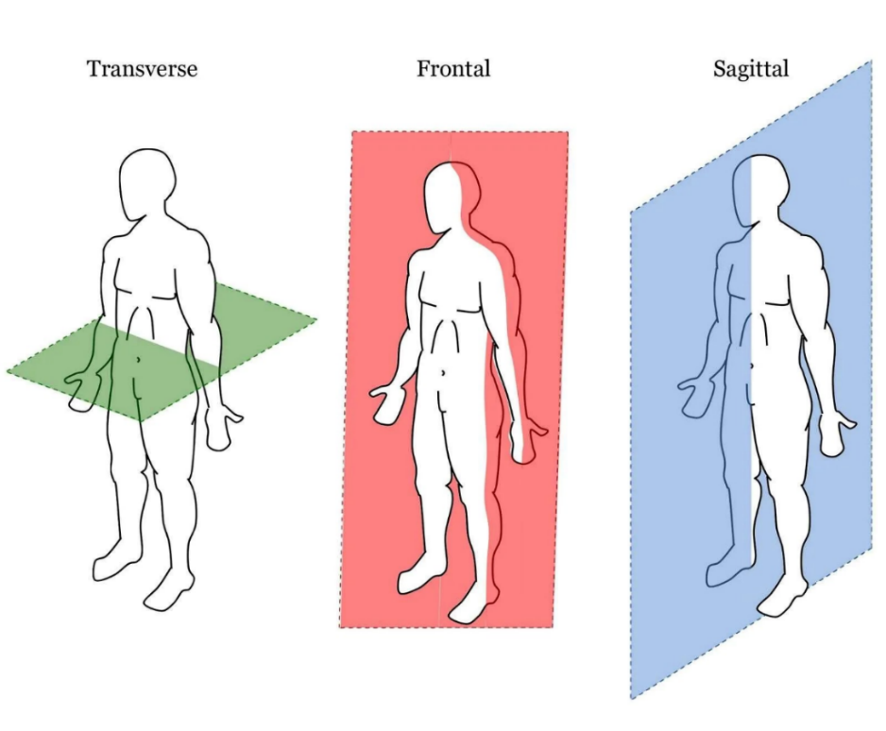

Image from: <https://physiquedevelopment.com/wp-content/uploads/2020/02/Planes-of-Motion.jpg>

**1. Transverse Plane** – this perspective captures visual information from the **top view** of the subject or performer.

**2. Frontal Plane** – also known as the coronal plane, it is the perspective where an observer is seeing the movement in the **front view**.

**3. Sagittal Plane** – this plane slices the body separating the left and right. It is the perspective where one seeing the **side view** of a posture or a movement.

**Major Movements in the Body**

Studying human movement can help us understand how the brain governs and coordinates daily motions, how the body adapts physiologically, neutrally, and psychologically to exercise, and how regular physical activity contributes to the prevention and management of chronic diseases. At this point of understanding movements, we must be conscious of three things: First is movement that has something to do with **bending and straightening**; second, movements in the human body also see body parts **going away from the center line** of the body; and lastly, movements that involves body parts **rotating in place**.

**1. Bending and Straightening Movements**

## **Flexion and Extension**

These bending and straightening are the ingredients of a dance routine, sports skills, or daily living tasks. We call these bending movements **flexion**, where a group of muscle is pulling a segment towards another. Straightening it back is called **extension,** where an opposite muscle pulls the segment back to a straightened or neutral position. There are also body parts that can bend opposite to the flexion side. We call this movement hyperextension, where the extension movement pass over the neutral or straight-line formation of the part.

**Direction:** During flexion, the leg moves backwards (posteriorly). During extension, it moves forwards (anteriorly).

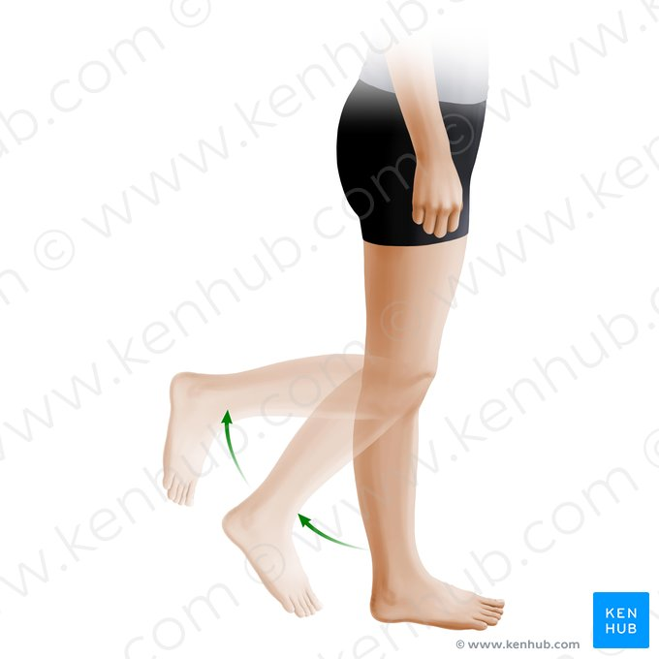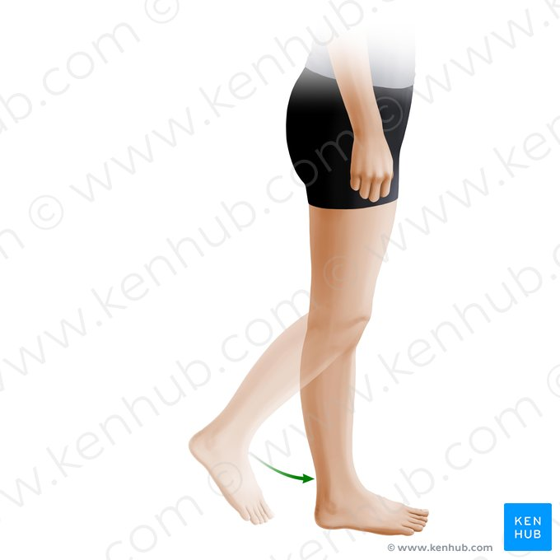

***Flexion of the Knee Extension of the Knee***

## **Hyperflexion and Hyperextension**

## Hyperflexion and hyperextension are exaggerated movements beyond the normal limit permitted by a joint. It can happen in limbs or the vertebral column and can result in ligament tear, damage, or dislocations.



**2.** **Moving Away from the Center**

## **Abduction and Adduction**

As an individual do movements like jumping jacks or arm swinging to the side, they do abduction and adduction movements. **Abduction** movements are swinging away, while **adduction** is swinging towards the center. Like the extension movement, we use a vertical line of reference to distinguish whether the swing is a **hyperadduction**.

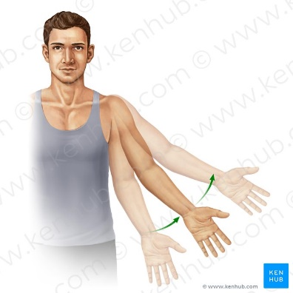**Direction:** During abduction, you are moving your arm/leg away from the median plane. During adduction, you are moving them towards the median plane.

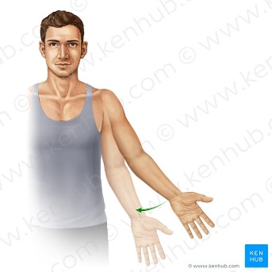

***Abduction of Arm Adduction of Arm***

**3. Rotation**

Rotation can occur within the vertebral column, at a pivot joint, or at a ball-and-socket joint. Rotation of the neck or body is the twisting movement produced by the summation of the small rotational movements available between adjacent vertebrae.

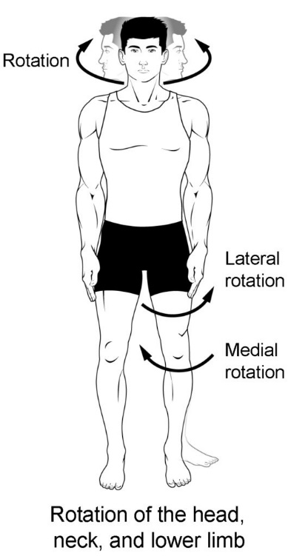

## **Specialized Movement**

The specialized movement involve musculoskeletal structure that result to a different movement view and standpoint.

## **1. Elevation and Depression**

This specialized movement can happen in the scapula, or the triangular bone and upper back.

**Direction:** During depression, the scapula moves directly downwards. During elevation, it moves directly upwards.

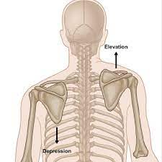

## **2. Pronation and Supination**

## Strictly speaking, pronation and supination are considered as two special types of rotation. They are restricted to the **forearm** and involve the radius twisting over the ulna.

**Direction:** The facing down (pronation) and facing up (supination) of the palm is the indicator of this forearm movement. It is facilitated by a rotational movement in the radioulnar articulation at the elbow joint.

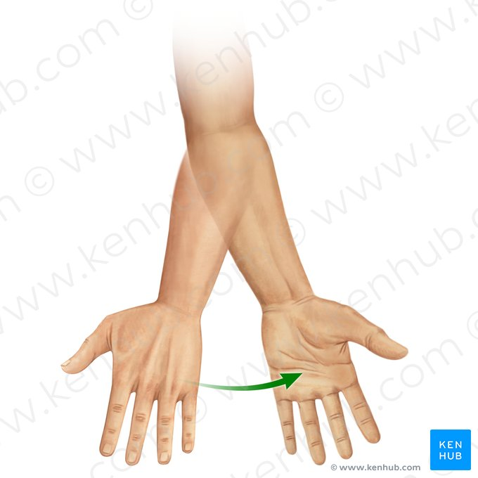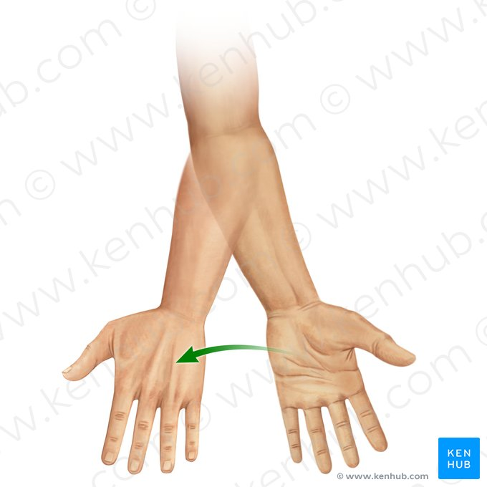

***Pronation of forearm Supination of forearm***

**3. Lateral Flexion**

This movement is applicable mostly to the trunk. It is a bending movement (flexion) to the side (lateral) of the torso, observable in the front view.

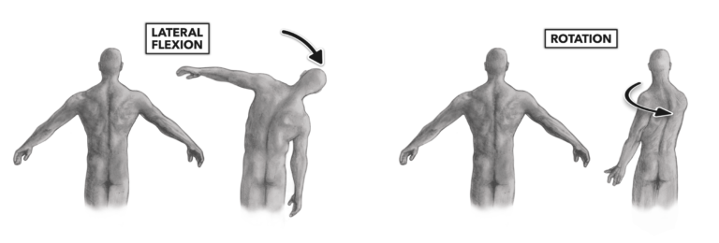

## **4. Circumduction**

## Circumduction is a special type of movement that is actually a combination of many other ones. The order must be sequential, but it can start from either flexion or adduction. The result is a circular movement. Due to the multitude of movements, circumduction is restricted to [*ball-and-socket type joints*](https://www.kenhub.com/en/library/anatomy/ball-and-socket-joint), such as the shoulder and the hip.

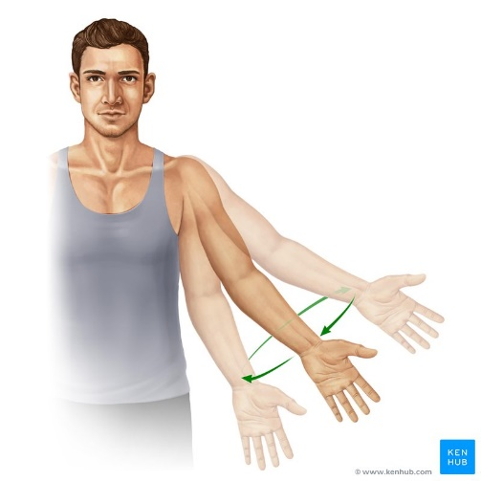

***Circumduction of upper limb (ventral view)***

## **5. Inversion/eversion**

## The antagonistic movements of inversion and eversion take place relative to the median place and are specific to the foot. In **eversion**, the plantar side of the foot is moved away from the median plane so that it is turned laterally. In **inversion**, the plantar side is moved towards the median plane, resulting in a medial turn.

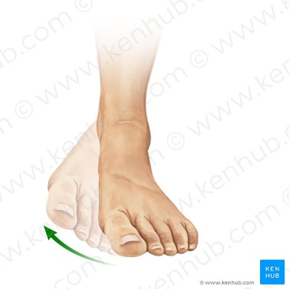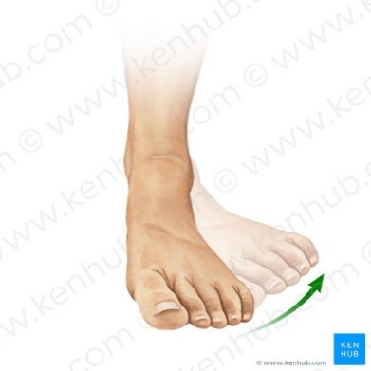

***Inversion of foot Eversion of foot***

|  |  |
| --- | --- |
| FLEXION | Bending |
| EXTENSION | Straightening |
| ABDUCTION | Moving away from the reference axis |
| ADDUCTION | Bringing closer to the reference axis |
| ELEVATION | Superiorly to the reference axis |
| DEPRESSION | Inferiorly to the reference axis |
| PRONATION | Medial rotation of the radius, resulting in the palm of the hand facing posteriorly (if in anatomical position) or inferiorly (if elbow is flexed) |
| SUPINATION | Lateral rotation of the radius, resulting in the palm of the hand facing anteriorly (if in anatomical position) or superiorly (if elbow is flexed) Mnemonic: '**S**upinate to the **S**un and **P**ronate to the **P**lants' (**S**upinate: palm towards the **S**un, **P**ronate: palm towards the **P**lants) |
| CIRCUMDUCTION | Combination of: flexion, abduction, extension, adduction |
| INVERSION | Plantar side toward the medial plane |
| EVERSION | Plantar side away from the medial plane |

**Summary Of Movements**

|  |  |  |
| --- | --- | --- |
| Major Joints | | Observable Movement  *(in Functional Position)* |
| Frontal Plane | | |
| Neck | * **Abduction** * **Adduction** | |
| Shoulder | * **Abduction** * **Adduction** * **Elevation** * **Depression** | |
| Trunk | * **Abduction** * **Adduction** | |
| Wrist | * **Flexion** * **Extension** * **Hyperextension** | |
| Fingers | * **Flexion** * **Extension** | |
| Hip | * **Abduction** * **Adduction** | |
| Ankle | * **Inversion** * **Eversion** | |

|  |  |  |
| --- | --- | --- |
| Major Joints | | Observable Movement  *(in Functional Position)* |
| Sagittal Plane | | |
| Neck | * **Flexion** * **Extension** | |
| Shoulder | * **Flexion** * **Extension** * **Hyperflexion** * **Hyperextension** | |
| Trunk | * **Flexion** * **Extension** * **Hyperextension** | |
| ELbow | * **Flexion** * **Extension** | |
| Wrist | * **Abduction** * **Adduction** | |
| Fingers | * **Abduction** * **Adduction** | |
| Hip | * **Anterior Tilt** * **Posterior Tilt** | |
| knee | * **Flexion** * **Extension** | |
| Ankle | * **Dorsiflexion** * **Plantarflexion** | |
| toes | * **Flexion** * **Extension** | |

|  |  |  |
| --- | --- | --- |
| Major Joints | | Observable Movement  *(in Functional Position)* |
| Transverse Plane | | |
| head | * **Rotation** | |
| neck | * **Protraction** * **Retraction** | |
| Shoulder | * **Rotation** * **Protraction** * **Retraction** | |
| Trunk | * **Rotation** | |
| Wrist | * **Pronation** * **Supination** | |
| Hip | * **Rotation** | |
| Ankle | * **Rotation** | |
| toes | * **Abduction** * **Adduction** | |

**Directional Terms**

Directional terms provide precise descriptions of a structure’s location. They allow a description of anatomical position by comparing location relative to other structures or within the rest of the body. With the body in anatomical position, there are specific terms to describe parts of the body with respect to each other. Please note that these terms are always used in reference to a body in anatomical position, regardless of that human body's actual position.

* **Superior and inferior** (cranial and caudal) are used when referring to parts of the body which are toward an end of the body. Superior structures are toward the head (cranial) while inferior (caudal) structures are toward the feet. Examples include the superior and inferior vena cava, which carry deoxygenated blood away from the head (superior) and from the lower body (inferior) to the heart.
* **Anterior and posterior** are sometimes used in place of superior and inferior, respectively. These words are used more often for animal anatomy and rarely and only with very specific meaning in human anatomy. Anterior refers to the side of the structure facing up in the standard anatomical position while posterior refers to the bottom side. For example, the pituitary gland has an anterior and posterior side, each of which secretes different types of hormones.
* **Dorsal and ventral** are sometimes used in place of anterior and posterior, respectively. Dorsal means the back side or upper side, while ventral means the frontal or lower side. These are mostly used with animal anatomy, but can be used in human anatomy as long as they are describing the side of an appendage. One example is the dorsal fin in fish, found on the upper side of the fish’s body.
* **Lateral** is used to describe anything closer to the sides of the body (toward the arms, in the standard anatomical position)
* **Medial** is used to describe anything toward the middle of the body. In general, many structures of the human body are bilateral and symmetrical with the middle of the body, such as the lungs or the arms.
* **Deep** refers to structures closer to the interior center of the body. For example, bones in an appendage are located deeper than the muscles. Superficial is used to describe structures that are closer to the exterior surface of the body. For example, the outer layers of skin are superficial to deeper layers of skin.
* **Proximal and Distal** describe one point relative to another. Proximal refers to a point closer to the reference point while distal refers to a point farther away. When describing appendages, the proximal end of the appendage connects the appendage to the body, while the distal end is away from the body.

|  |  |  |
| --- | --- | --- |
| **Directional Terms** | **Meaning** | **Example** |
| Supine | lying face up | A person lying face up is in the supine position. |
| Prone | lying face down | A person lying face down is in the prone position. |
| Superior / Cranial | above or higher up | The nose is superior (or cranial) to the chin. |
| Inferior | below or lower down | The knees are inferior to the pelvis. |
| Caudal | below or lower down - toward the tail bone from higher up | The pelvis is caudal to the stomach. |
| Medial | toward the midline | The sternum is medial to the shoulders. |
| Lateral | toward the side | The ears are lateral to the nose. |
| Superficial | toward the body surface | The skin is superficial to the heart. |
| Deep | toward the body core | The heart is deep to the ribs. |
| Anterior / Ventral | front or toward the front | The toes are anterior (or ventral) to the heel. |
| Posterior / Dorsal | back or toward the back | The spine is posterior (or dorsal) to the sternum. |
| Proximal | **for limbs only:** closer to the shoulder (upper limb); closer to the hip (lower limb) | The elbow is proximal to the wrist. |
| Distal | **for limbs only:** further from the shoulder (upper limb); further from the hip (lower limb) | The toes are distal to the knee. |

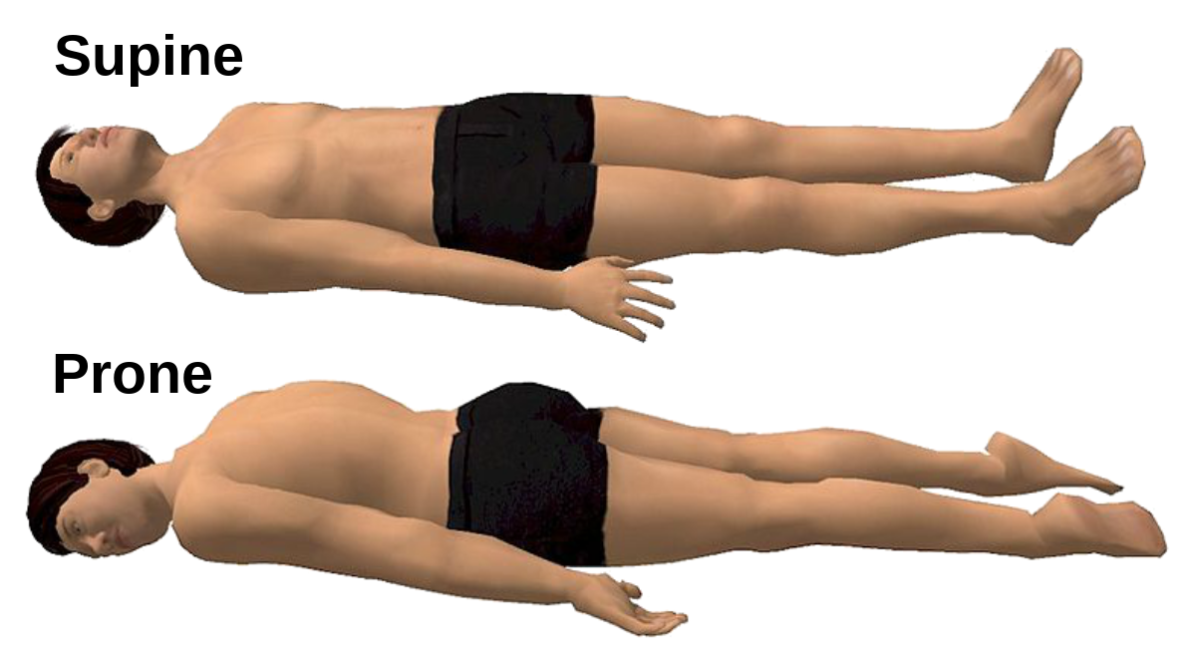

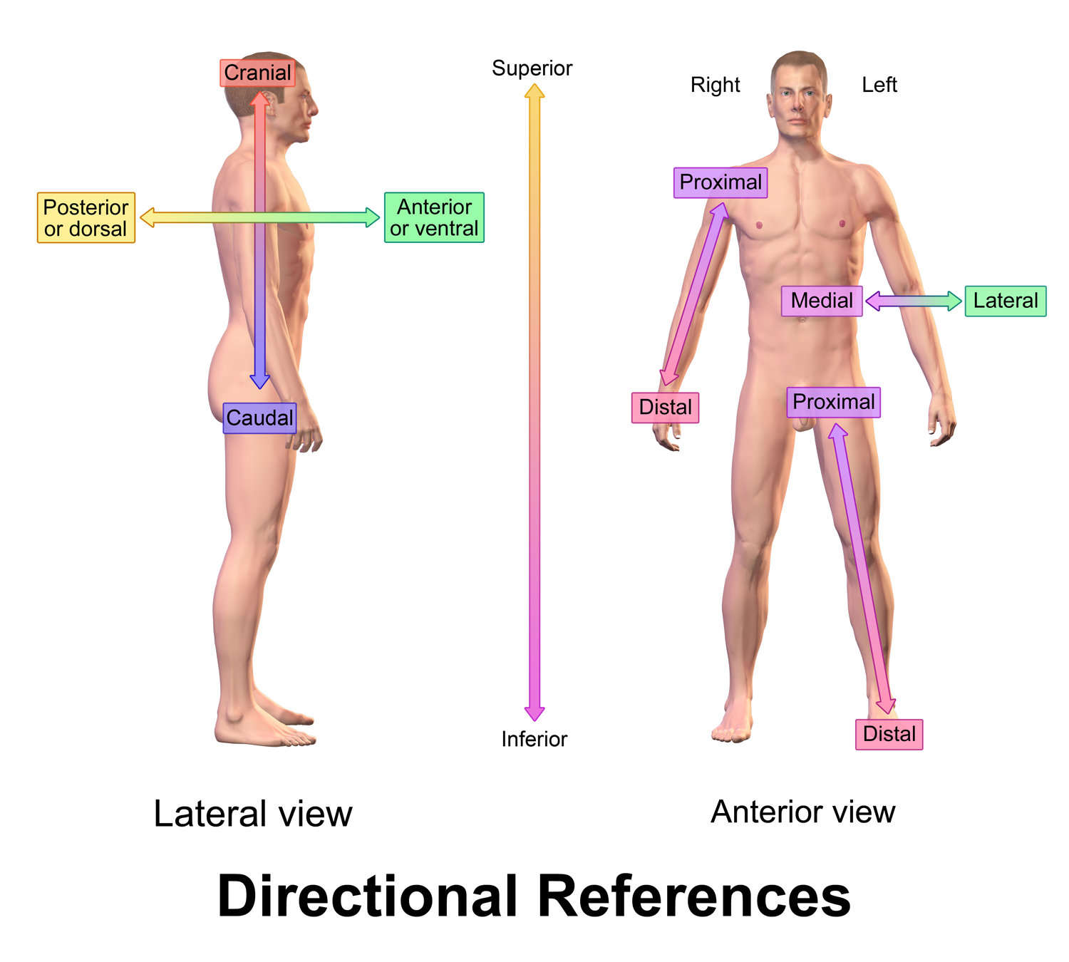

**Basic Body Positions**

**Standing Positions**

1. **Standing-** Feet close together or in parallel position. Arms both on sides.
2. **Stride Position-** Stand on both feet with one foot distance apart. Arms both on sides.
3. **Lunge Position-** Bend one knee, the other leg is extended backward. The weight is on both feet. Hands on hips.
4. **Half-Knee Bend-** Feet together, bend knees to about 45° angle; feet flat on floor, body erect; hands on hips.
5. **Full-Knees Bend/Squat Position-** The knees are fully bent, sit on the heels of the feet. The weight of the body is on the balls of the feet.

**Sitting Positions**

1. **Long Sitting Position-** Sit with legs extended forward, toes pointed; trunk erect and hands on hips.
2. **Hook Sitting Position-** Sit on buttocks, bend knees close to the body. Trunk erected, hands on shin of the legs.
3. **Long Sitting Rest Position-** Legs and toes are extended forward; hands at the rear on the floor. Elbow and body straight.
4. **Tuck Sitting Rest Position-** Sit on buttocks, bend knees close to body; round back so that the forehead and the knees are in contact; holdshin of legs.
5. **Stride Sitting Position-** Sitting on buttocks, spread legs apart, trunk erect, hands on thigh.
6. **Side Sitting Position-** Sitting on buttocks, bend right or left leg in front; other leg extended sideward. Hand on knees.
7. **Hurdle Sitting Position-** Sitting on buttocks, bend right leg at the back about 90 angles, the other leg extended diagonally forward.
8. **Heel Sit-** From kneeling position, sit on the heels of the feet, toes pointed. Hands on hips.
9. **Cross Sitting Position-** Sit on the floor. Bend both knees and cross legs in front. Arms in Indian position.
10. **Frog Sitting/Tailor Sitting Position-** Sit on the floor. Fully bend both knees and bring legs in front. Heels and toes of feet touching together. Hands on knees.

**Kneeling Positions**

1. **Kneeling Position-** Kneel on both knees, knees close together, body erect, hands on hips.
2. **Stride Kneeling Position-** Kneel on both knees, with knees apart.
3. **Half Kneeling Position (Right or Left)-** Kneel on right, left in half-kneeling position in front. Hands on hips.
4. **Half Kneeling Position (One leg extended sideward)-** Kneeling on one leg, the other leg extended sideward, forward or backward.

**Lying Positions**

1. **Back or Supine Lying Position-** Lying on the back, the body is well extended, arms overhead, toes pointed.
2. **Front or Prone Lying Position-** Body is well extended and in front of the body in contact with the floor. Toes pointed, arms forward.
3. **Side Lying Position-** With the body well extended, the side of the body is in contact with the floor, one hand on the floor overhead and other hand bent close to chest palms on floor. Toes pointed.
4. **Hook Lying Position-** In a back lying position, bend knees, with the feet close to buttocks, feet flat on the floor. Arms overhead.
5. **Tuck Lying Position-** Lying on the back, pull the knees close to the forehead, hold shin of legs.

**Arm Support Positions**

1. **Supine or Back Arm Support-** From a long lying position, lift the body with straight arms support. Body, legs, and toes are well extended in one straight line.
2. **Prone or Front Arm Support-** From a front lying position, lift the body to front arms support. Body, legs and toes well extended and are in one straight line.
3. **Side Arm Support-** The body is supported with the right or left arm; the body is well extended.

**Four Based Position**

1. **Dog Stand Position-** From a kneeling position, place the hands on the floor, elbows straight, toes pointed; the knees and hands are the base of support.
2. **Bridge Stand Position-** From a hook sitting lift the trunk, legs and arms in a right angle with the trunk.

**Hand Positions**

1. **Hand on Waist-** Place hands on waist, fingers pointing front, thumbs pointing backward.
2. **Hand on Chest-** Palms facing down, thumbs touching the chest, elbows in line with the shoulders.
3. **Hand on Shoulders-** Bend arms from the elbow, finger tips touching the shoulders, elbow in line with the shoulders, rib cage lifted.
4. **Hand on Neck-** Bend arms from the elbows, place hands behind the neck, fingertips meeting each other, elbows in line with the shoulders.
5. **Hand on Hips-** Place hands on hips, thumbs pointing back and fingers pointing front.

**Arm Positions**

1. **Arms Forward-** Raise arms forward with palms facing each other. Hands in line with the shoulders, elbow slightly extended.
2. **Arms Sideward-** Raise arms sideward, palms facing down, finger tips in line with the shoulder.
3. **Arms Upward-** Raise arms upward, palms facing each other, elbows touching the ears, the whole arm is in line with the body.
4. **Arms Oblique Positions**

* Forward downward
* Backward downward
* Sideward downward
* Sideward upward

1. **Arms in T Position-** Bend elbows at shoulder level. Forearm parallel to elbows. Palms facing the body. Fingers together and pointing downward.
2. **Arms in Reverse T – Position-** Bend elbows at shoulder level. Forearm parallel to elbow. Palms facing the head. Fingers together and pointing upward.